Question:
Does water have a "texture"?

Answer:
Water is not usually described as having texture, nonetheless, water does have many interesting physical and structural properties that describe how it feels.
Water (H₂O) is a molecule made of one oxygen (red) atom and two hydrogen (white) atoms, shown below. They are covalently bonded together to form a bent molecule. The oxygen also has two lone pairs of electrons, which are electrons that do not participate in bonding.
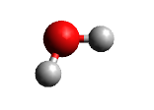
Water has a property called cohesion, which means that the water molecules are attracted to each other and stick together. In water, cohesion is stronger than in most molecular liquids because the inter-molecular forces are cause by hydrogen bonding between the molecules. Hydrogen bonding occurs when a hydrogen atom, which is bonded to a highly electronegative atom (fluorine, oxygen, or nitrogen) is also near another highly electronegative atom. In water, the electronegative oxygen atom bonded to the hydrogen pulls electron density away from the hydrogen creating a partial positive charge on the hydrogen and a partial negative charge on the oxygen. The image below shows and electrostatic surface around a water molecule, where partial positive regions are shown in blue and partial negative regions are shown in red.
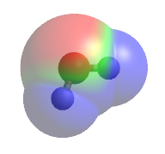
Negatively and positively charged atoms attract so a hydrogen bond forms between the hydrogen of one water molecule and the oxygen of another. The hydrogen bond is depicted by a dashed line between two water molecules shown below. The strong intermolecular interactions also lead to a relatively high viscosity, which is probably the best description of the “texture” of water. Viscosity is the resistance to flow in a fluid. Water’s high viscosity explains why it is harder to move your hand through water than through air.
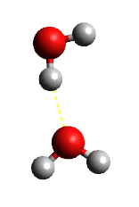
Because of the shape of the water molecule, the hydrogen bonds cause the molecules to arrange in a four-coordinated pattern, where each water is surrounded by four others – one oxygen bonded to each hydrogen and two hydrogens bonded to the oxygen. When the water molecules are perfectly organized (as in ice), they have the structure shown below on the left. In liquid water, the molecules are more disordered, so while they maintain a similar short range order, the structure ends up looking more like the structure shown below on the right.
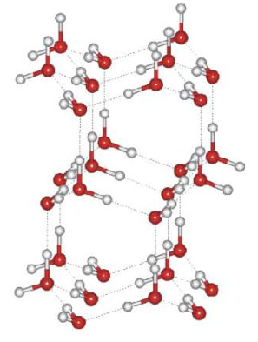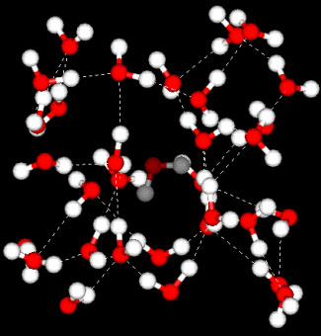
Images of water structure from <http://www-ssrl.slac.stanford.edu/nilssongroup/pages/project_liquid_structure.html>

The order of liquid water can be described by a radial distribution function, g(r) (also called a pair correlation function). A radial distribution function is a mathematical expression that tells us where the water molecules are relative to each other along a radius, r. The units of r are usually measured in angstroms (one angstrom is 10⁻¹⁰ m). When there is a peak in g(r), it means that on average, there are a lot of atoms at that distance from each other, and when there is a dip in g(r), it means there are not many atoms at that distance from one another. The figure below shows the expected g(r) for water. g_{OO}(r) tells us the distance from one oxygen to another, g_{OH}(r) tells us the distance between oxygen and hydrogen atoms, and g_{HH}(r) tells us the distance from one hydrogen to another.
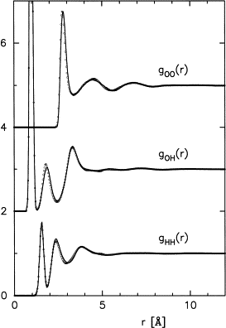
Figure from Soper, A.K.; Chemical Physics, 2000, 258, 121-137.

The structure of water can be detected experimentally using x-ray or neutron scattering. The Fourier transform (a mathematical operation) of g(r) gives the structure factor which predicts scattering intensities in diffraction experiments.

If you would like to learn more about water, here is a website from UC Davis that explains the unusual properties of water:
http://chemwiki.ucdavis.edu/Physical_Chemistry/Physical_Properties_of_Matter/Intermolecular_Forces/Unusual_Properties_of_Water

References:
http://chemwiki.ucdavis.edu/Physical_Chemistry/Physical_Properties_of_Matter/Intermolecular_Forces/Unusual_Properties_of_Water
Soper, A.K.; Chemical Physics, 2000, 258, 121-137.
http://www-ssrl.slac.stanford.edu/nilssongroup/pages/project_liquid_structure.html

