Hi Demetrio,

The way I am understanding this question, is you would like to be in a room, whose walls are entirely see through and magnify the outside.

The windows will be acting like a lens. For this reason, adding water between the windows is not a good idea. Windows, are made of glass which is an excellent optical material and allows a lot of light to pass through it. Water has a different index of refraction than glass and will cause the image to be distorted and some of the light to not pass through.

Also note, that just using one window, or lens, will produce a distorted image. There are ways to get around these distortions or aberrations, which if you are interested in I recommend you look up Nikons optical objective information.

The equation which will help the most is the lens maker equation.

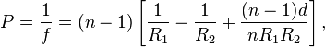

The radius of curvature of the windows would depend on where the object you want to magnify is located and where you will be standing.

For example, if you want some trees outside this building to be magnified 5x. The trees are located 1 meter away from the window and you are 5 m inside on the other side of the window. The image will be 5x the size of outdoor image.

s = distance to trees
s’ = distance to viewer
f= focal length of lens

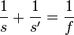

The focal length of the lens is 0.833m (5/6 m). From the focal distance, you can find the radius of curvature.

Lets call

R1=Radius of curvature on the left side of the lens
R2 = Radius of curvature on the right side of the lens
n= index of refraction of lens material

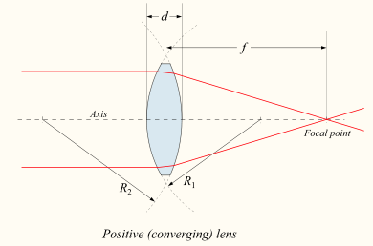

This image comes from http://en.wikipedia.org/wiki/Lens_(optics)

The thin lens equation is below (d is small), which assumes the edges of your lens are close compared to the radius of curvature. This equation is modification of the full lens equation and is easier to understand and true to first order.

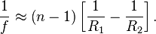

In the case I described above

1/f = 6/5
n= 1.5 (The index of refraction for most glasses)
Using the numbers I gave

6/5 = (0.5)*(1/R1 – 1/R2)

Lets set R1= - R2. Remember R2 is negative since it is facing opposite R1.

6/5= (0.5)*2/R1

1/ R1 = 6/5

R1 = R2 = 0.833 m or 5/6 m

Radius of curvature for each side of the lens would be 0.833.

I invite you too look at the Wikipedia page as well as http://www.animations.physics.unsw.edu.au/jw/light/lenses_and_images.htm
to learn more about optics

